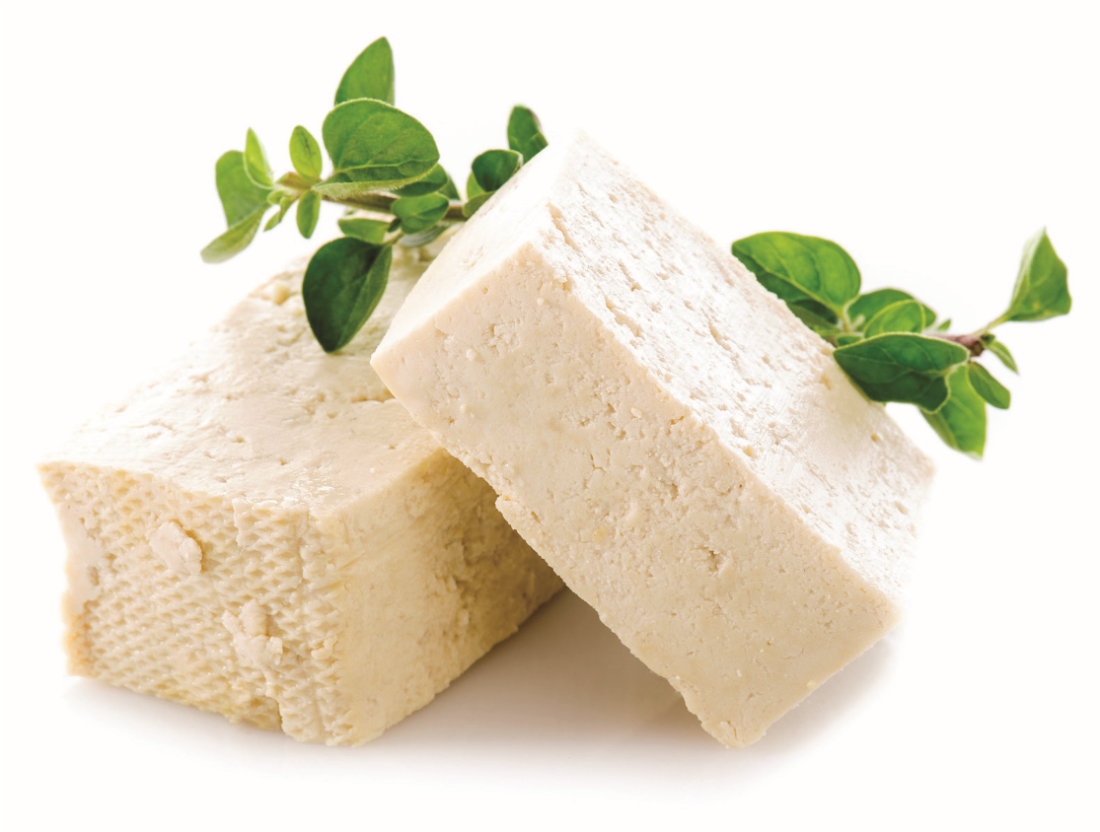

WHAT IS TOFU?
Tofu, also called bean curd, is a food made by coagulating soymilk and pressing the resulting curds into soft, white blocks.
Tofu is an easy ingredient to use in any recipe because of its ability to adapt to a dish. In its original state, tofu is rather bland. It acts as a sponge, and takes on flavors that you pair it with. Tofu is one of the most versatile lean proteins out there!
WHERE TO FIND

You can find packages of silken & water packed tofu in the refrigerated section (typically the produce area) at a supermarket or in the health food
section.
SILKEN TOFU
Silken Tofu comes packaged in a small, rectangular aseptic cardboard box (it is shelf stable until opened). It comes in soft, firm and extra firm consistencies. There is a small amount of liquid that should be drained after opening the package. Because of its’ light, fluffy and cream-like qualities, silken tofu is best used in smoothies, dressings, dips and desserts. Soft silken tofu combined with greek yogurt is a simple and healthier alternative to cream cheese and mayonnaise in every day recipes. Firm or extra firm silken tofu sets up nicely and results in excellent pies or when a firmer consistency is desired.
WATER-PACKED TOFU
Water-Packed Tofu comes packaged in a container with water. It is also now available as vacuum packed, without water surrounding the tofu. It comes in soft, firm and extra firm textures. This tofu is ideal for entrees and recipes when tofu should maintain a desired shape and texture. The soft texture will not work in a stir-fry as it will not hold its shape. In order to achieve the firmest and most desirable texture, press the tofu. This process removes excess water and prepares the tofu to absorb flavors.
TO PRESS WATER-PACKED TOFU
Begin by draining the water from the package, then slice the tofu into desired pieces. On a paper towel-lined plate or pan, arrange the tofu pieces. Place a layer of paper towels on top of the tofu pieces, then place a flat, heavy object on top. (For example, a glass baking dish or skillet). Press for at least a half hour, replacing paper towels after 15 minutes or as needed.
The tofu is now ready to be marinated, rubbed or seasoned.

NUTRITIONAL VALUE
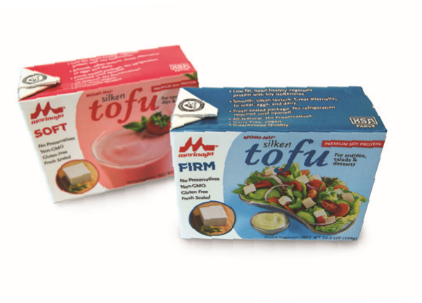
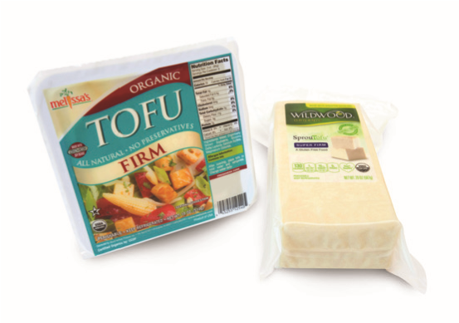
SILKEN TOFU WATER-PACKED TOFU
% of Daily Value % of Daily Value
3 oz. = 1 serving3 oz. = 1 serving
1 cup = 10 grams of soy protein1/2 cup = 12.5 grams of
Total Calories: 50 soy protein
Total Fat: 2.5 grams, 4% Total Calories: 70
Saturated Fat: 0 gramsTotal Fat: 4.5 grams, 7%
Trans Fat: 0 gramsSaturated Fat: .5 grams, 3%
Calcium: 2% Trans Fat: 0 grams
Iron: 4% Calcium: 10%
Iron: 6%
thesoyfoodscouncil.com | Follow us on Twitter and Facebook.

